Oak Forest Elementary #OFESTRONG Virtual Auction FAQs
March 26, 2021

1. How do I bid on silent auction items?
To bid on silent auction items you must register for the auction. Please follow these simple instructions:

Step 1: Register
Register your phone number and credit card at: https://qtego.net/qlink/oakforestpta and click on “Register for the Event.”
Once you register, Qtego will send you two text messages to the phone number you registered with bidding instructions.
You may also register your phone at the event, with a Qtego representative in an orange shirt.

Step 2: Start Bidding!

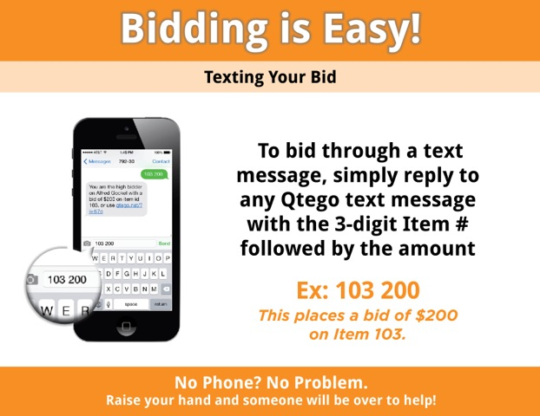
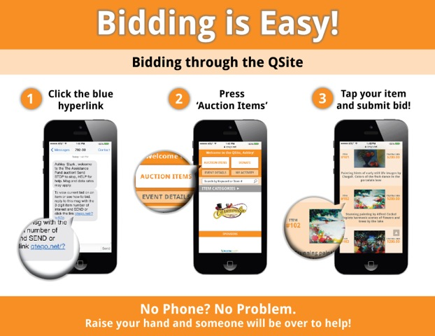

2. Do I have to attend the virtual event to bid on an item? No! Anyone can access our bidding website beginning March 24th at noon. Please note if you win an item you will be responsible for picking the item up at The Handler Home, 1343 Wakefield, on March 27, 2021 between 9am and noon. Please help the auction committee out by marking your calendar now for the pickup of your potential winnings!

3. What if I want to see the items you will have as part of the silent auction? Mark Wednesday, March 24 from 4pm-6pm on your calendar! We will have a live preview of some of the items along the wave at Oak Forest Elementary! We will have music from Boosterthon and a visit from the Kona Ice Truck. A portion of all purchases at the Kona Ice Truck will come back to the OFE PTA!

4. How do I receive my pre-ordered sponsorship items? Visit us at Oak Forest Elementary on Wednesday, March 24 between 4pm & 6pm to collect the #ofestrong items you purchased so you can use them for your drinks during the virtual auction!

5. What will I do for dinner on March 26 during the virtual event? Your auction committee has partnered with 3 local restaurants to put together some fantastic dinner packages. Check out the options from Tony’s Mexican Restaurant, Millie’s Kitchen & Cocktails and The Union Kitchen and order yours today!

6. What is an Instabuy? Instabuys are items that have a certain number available and you purchase them outright- no need to bid! Once you claim one, it’s yours. This year we have parties and merchandise to choose from. Remember, all merchandise will need to be picked up the day after auction. See #1 for details.

7. Will there be a live auction? Yes! The live auction will happen during the live stream on March 26 so be sure to click our auction link a bit before 8pm to bid on our special items. We have several including but not limited to vacation homes, a fishing trip, a private dinner, and the ever popular Raise the Flag!

8. When can I start bidding? Bidding will begin on Wednesday, March 24 at noon. Don’t worry- we will remind you via Living Tree, Facebook and Instagram! Bidding on all silent auction items will end at 10:30pm on Friday, March 26.

9. I have another question that was not addressed in the FAQ. No worries, contact auction@oakforestpta.com for additional questions.

